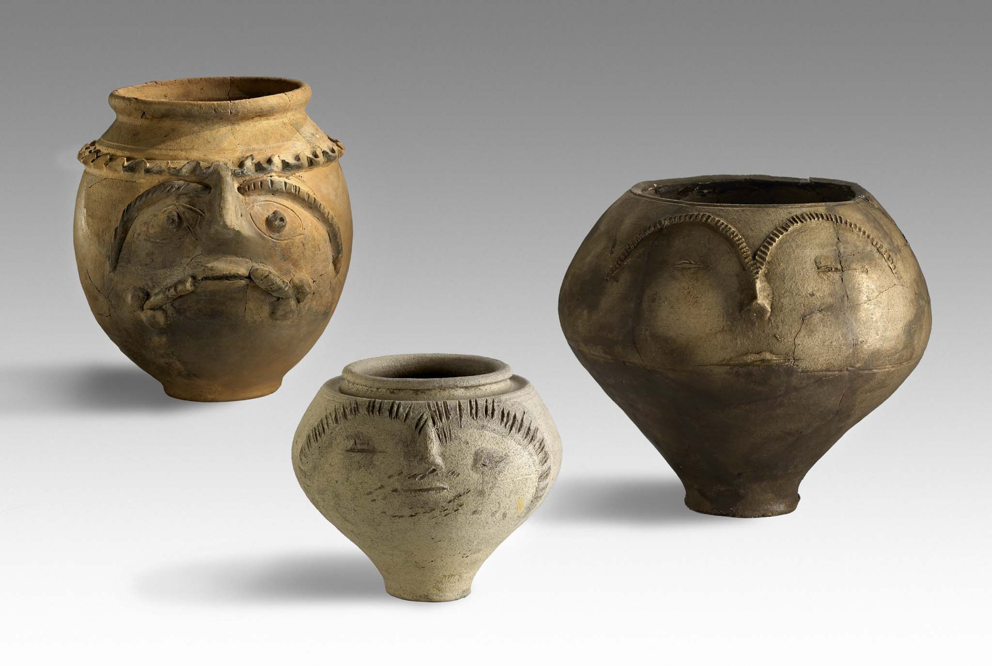
Second Circular

29th Congress of the Rei Cretariae Romanae Fautores

Xanten, Germany, 21st – 26th September 2014

Dear Fautores, friends and colleagues,

first of all, we would like to thank you for your support and your numerous applications. All submissions are revised by the RCRF-committee and the congress organization team. We have received over 180 registration forms, so we are no longer accepting any further submissions.

Congress Fee

The congress fee is 220€. The fee includes: Access to opening ceremony and welcome reception, access to LVR-Archäologischer Park Xanten / LVR-RömerMuseum, access to closing ceremony, access to all scientific sessions and poster displays, access to exhibition and pottery displays, congress kit, coffee breaks, lunch or dinner once a day, excursions.

Conference Programme

All submitted presentations are going through a selection process.
A list of all successfully submitted presentations will be announced on the official website in the next few days. Please check your name and lecture/poster theme for discrepancies. In case of mistakes please contact the organization team immediately (RCRF-29.APX@lvr.de).
In case you don’t want your name being published on a website, please contact us as soon as possible.

A provisional programme will be released in February on the conference website: http://www.apx.lvr.de/english/archaeologicalpark/research/congressofrcrf.htm
http://www.fautores.org/pages/congress_2014_Xanten.htm

All further changes to the programme will be advertised on the website: http://www.apx.lvr.de/english/archaeologicalpark/research/congressofrcrf.htm
http://www.fautores.org/pages/congress_2014_Xanten.htm

Accommodation

Please take care of your accommodation as early as possible (holiday season!). Consider the transport possibilities from your hotel to the congress venue!
Use the following link of the Tourist Information of Xanten (tix) for booking. There you can find a list of all hotels and holiday homes in Xanten and its vicinity:

http://www.xanten.de/de/besucherinformationen/branchen-xanten-exklusiv/unterk%C3%BCnfte/hotels

http://www.xanten.de/de/unterk%C3%BCnfte/urlaub-in-historischen-gem%C3%A4uern

For direct booking (in English, Dutch, French and German):
http://www.xanten.de/de/unterk%C3%BCnfte/buchung-zimmer

We reserved 50 rooms in the hotels “Nibelungenhof” and “Hövelmann’s” in the centre of Xanten (double and single rooms). If you book there please be sure to refer to the RCRF-Congress (German Keyword: RCRF-Tagung).

Transport

It’s a short walk of 15 minutes from the centre of Xanten to the congress venue. Nevertheless, you have the opportunity to rent bicycles to get around in Xanten and its vicinity. For further information: http://www.niederrheinrad.de/.
In addition, 12 – 15 bicycles are available in the LVR-Archaeological Park for free.

Payment

Please transfer the conference fee of 220€ to one of the following accounts:

LVR-Archäologischer Park Xanten
Account No.: 60 061
Bank Code: 300 500 00 (Bank: Landesbank Hessen-Thüringen)
IBAN: DE 84 3005 0000 0000 060061
BIC: WELADEDD

LVR-Archäologischer Park Xanten
Account No.: 564 501
Bank Code: 370 100 50 (Bank: Postbank Niederlassung Köln)
IBAN: DE 95 3701 0050 0000 564501
BIC: PBNKDEFF370

As reason for payment please write: Deb.2000233989/RCRF.

All payments have to be made by the 31st May 2014. Any registration for which the fee has not been received by that date will automatically be cancelled. (If you know earlier that you will not be attending the congress, please let us know!)
If you want to cancel your registration after the fee has been paid, your fee may be refunded at the discretion of the organizer, except for transfer fees for foreign bank transfers.
Payments will be made according to the daily updated currency exchange rate.

Lectures

The number of lectures is limited due to the tight schedule. As the submitted lectures exceed the given limit, the organization team will have to ask some participants for a poster instead.
To follow the tight congress schedule we kindly ask you to not exceed the given time of 15 minutes for lecture and 5 minutes for the following discussion. The conference languages are English, French, German, Italian and Spanish. For a better understanding, we kindly request you to prepare PowerPoint presentations with short English captions or summaries.
Please check profile drawings and ceramics for good visibility. Profile drawings should be filled and ceramic illustrations should be enlarged.

Posters

All posters will be displayed throughout the congress. Multiple sessions will be scheduled giving the opportunity for participants to discuss the content with the poster authors. Authors are invited to send the poster data by email to the organization team for printing in advance (DIN A2 [42,0 x 59,4 cm], pdf, 300 dpi; printing in advance is for free). Please check profile drawings and ceramics for good visibility. Profile drawings should be filled and ceramic illustrations should be enlarged.
The deadline for poster submission is 15th July 2014.

If requested, authors may also print their poster at their own expense. In this case please be sure that the print meets the following conditions: DIN A2 (42,0 x 59,4 cm) and 300 dpi. We offer the opportunity to send your printed posters in advance for installation prior to the congress. Of course, you still may submit your printed posters on your arrival in Xanten.

Abstracts and Publication

A short summary of all lectures and posters will be compiled in the abstract booklet. All participants will receive a copy on their arrival.
The publication of papers in the Acta of the RCRF will take place according to the usual pattern (subject to peer review). Please note that in order to receive the Acta automatically for free it is necessary to be a member of the RCRF. As non-member you can order the Acta from the RCRF editor as well. Deadline for submission will be 31st December 2014 prospectively.

Post-Congress Tour

The post-congress tour will take place in Cologne. The conference fee does not include the post-congress tour! The fee and the programme for the post-congress tour will be announced in the 3rd Circular.

Visa

In case of needing an official confirmation of registration for your visa application, please do not hesitate to contact us.

If you have any questions please contact the conference organization team (RCRF-29.APX@lvr.de). Check the conference website (http://www.apx.lvr.de/english/archaeologicalpark/research/congressofrcrf.htm) for updates and further information.

Yours sincerely,
Congress Organization Team

