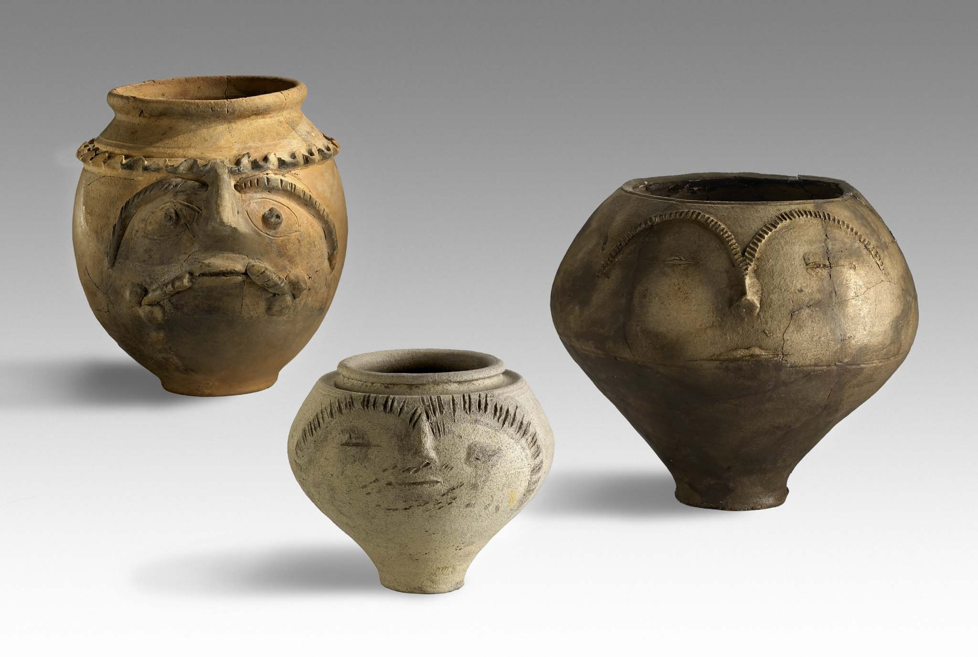
Third Circular

29th Congress of the Rei Cretariae Romanae Fautores

Xanten, Germany, 21st – 26th September 2014

Dear Fautores, friends and colleagues,

all submissions have been reviewed by the convener and the organization team. A provisional list of all lectures and poster presentations is attached to this circular. As we stated in the Second Circular, we had to convert some papers into posters due to the tight schedule of the congress. We thank all participants for their understanding and willingness.
The final list of papers and posters will be announced by the 31st July 2014.

Below you find further information on the congress:

Provisional Scientific Program

Please check the titles of your submitted lectures and posters. If there are any discrepancies please contact the Organization Team immediately (RCRF-29.APX@lvr.de).

Please be informed that each co-author who wishes to attend the congress must be registered and pay the congress fee. If you are not registered yet, send the filled registration form to the Organization Team as soon as possible (RCRF-29.APX@lvr.de).

Acta

Papers and posters presented at the Congress will be published in the Congress Acta and there will be no distinction between papers and posters.
Free copies of the Acta are restricted only to members of the RCRF association. As non-member you can order the Acta from the RCRF editor.

Grants

In March the RCRF council decided upon the grants for the congress. Those who have been granted a financial support were informed. For further information please contact Dr. Zabehlicky-Scheffenegger or the Organization Team (RCRF-29.APX@lvr.de).

Post-congress tour

The fee for the post-congress tour is 75€. The fee includes: transport from Xanten to Cologne and back (via Düsseldorf); lunch; all fees for guided tours and entries. Please notice that costs for accomodation are not included!
Please take care of your supplies for the rest of the day (beverages, food, etc.).

Deadline for binding registration is 31st May 2014.
Deadline for payment is 15th June 2014 (for post-congress tour fee and congress fee!).
Cancellations after the 31st May 2014 will be charged a fee for administrative expenses.

Payment details for post-congress tour

Please transfer the excursion fee of 75€ to one of the following accounts:

LVR-Archäologischer Park Xanten
Account No.: 60 061
Bank Code: 300 500 00 (Bank: Landesbank Hessen-Thüringen)
IBAN: DE 84 3005 0000 0000 060061
BIC: WELADEDD

LVR-Archäologischer Park Xanten
Account No.: 564 501
Bank Code: 370 100 50 (Bank: Postbank Niederlassung Köln)
IBAN: DE 95 3701 0050 0000 564501
BIC: PBNKDEFF370

As reason for payment please write: Deb.2000233989/RCRF.

If you have any questions please do not hesitate to contact the Congress Secretary. Check the congress website at http://www.apx.lvr.de/archaeologischerpark/forschung/rcrftagung.htm for updates and information.

Yours sincerely,

Congress Organization Team

