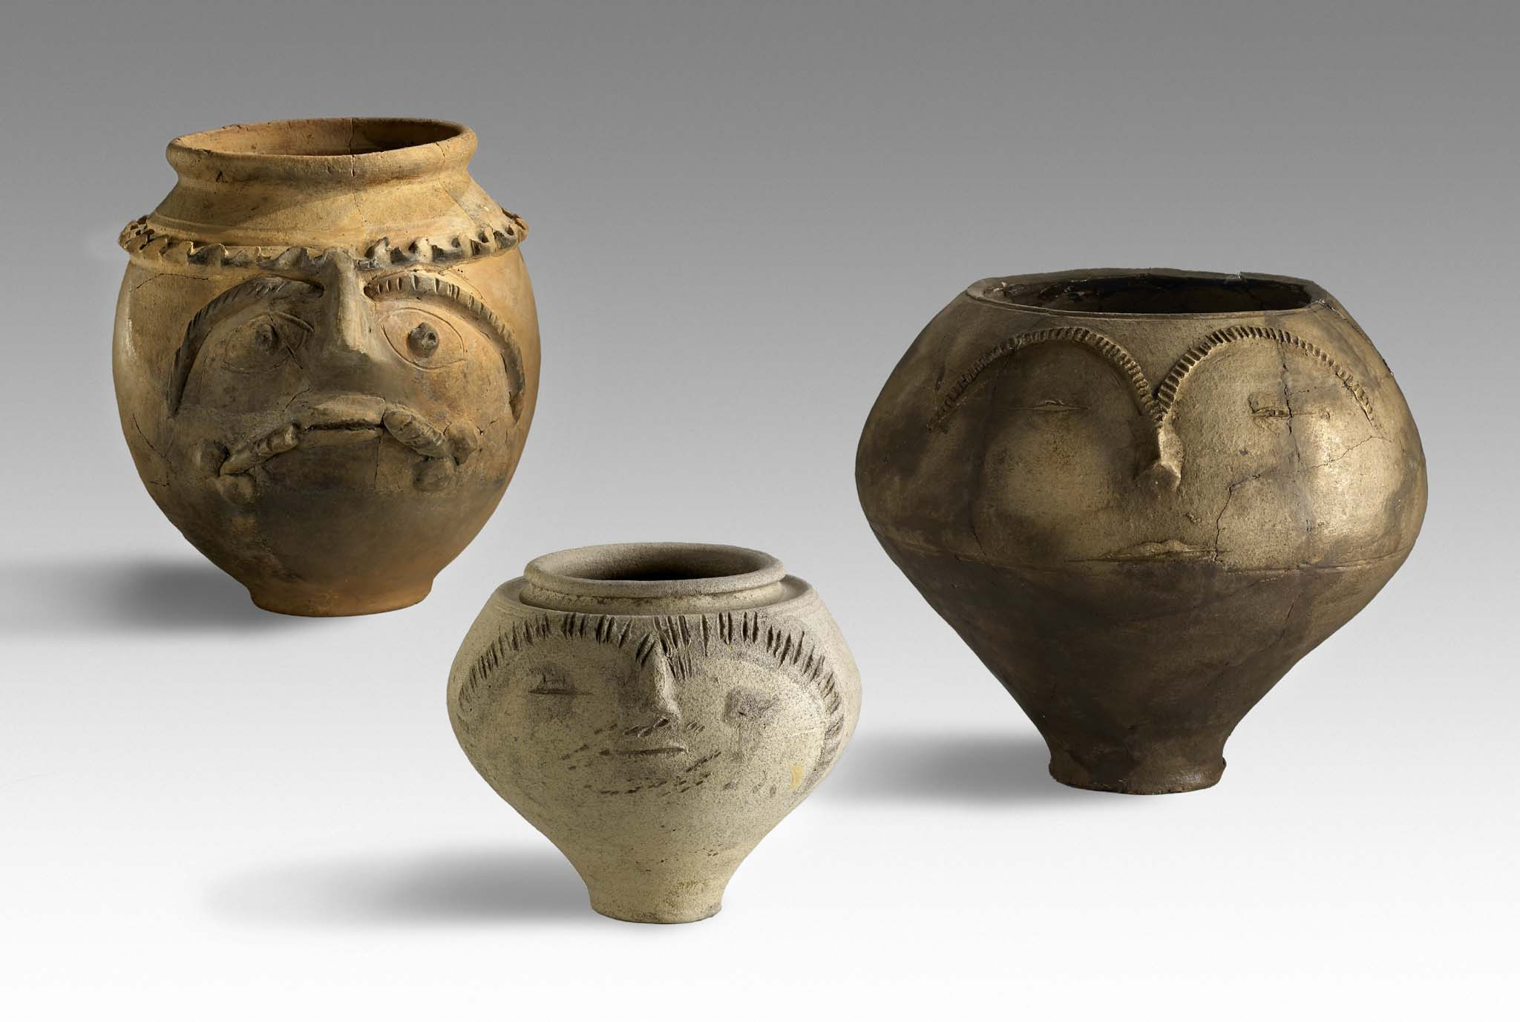

29th Congress of the Rei Cretariae Romanae Fautores

Xanten, Germany, 21st – 26th September 2014

List of Posters

Eastern provinces

- Dr. Charikleia Diamanti – Prof. Em. Sophia Kalopissi-Verti – Prof. Em. Maria Panayotidi-Kesisoglou – Prof. Platon Petridis, The Red Slip Wares in Hala- sarna, Kos: The Relationship between the Fine Ware Imports and the Eco- nomic Wealth of a Late Roman Aegean Settlement
- Dr. Bahadır Duman, African Red Slip Ware in Lydian Tripolis
- Dr. Charikleia Diamanti, The Late Roman Amphoras Workshop of Paros Is land in the Aegean Sea – Recent Results
- Prof. Andrei Sazanov, The Chronology of Amphoras and Red Slip Wares from Northern Black Sea Coast Contexts of the Second Half of the 4th – Beginning of the 5th Century AD

Africa

- Dr. Cristina Mondin, Lamps from Kom al-Ahmar near Alexandria, Egypt

The Balkans and the Danube region

- Prof. Piotr Dyczek, Amphorae from barracks of Legio VIII Augusta and
Legio I Italica in Novae
- Ludmila Kovalevskaya M.A., An Early Flavian Deposit of Amphorae from the Legionary Fortress at Novae (Lower Moesia)
- Assoc. Prof. Gergana Kabakchieva, Die neuen Funde der importierten Terra Sigillata in Moesia
- Dr. Dorel Bondoc, Roman Amphorae from Slaveni, Romania
- Alexandra Nagy, Import and Imitation. Thin-walled Pottery with Barbotine Decoration in the Area of Aquincum
- Balász Rikker – Péter Vámos, Archaeometrical Investigations on
Ceramics from the Eastern Cemetery of the Aquincum Civil Town
- Nikoletta Varga, Raetian Ware in Aquincum
- Dr. Tino Leleković, Imports and local production in Pannonia during 2nd and 3rd century
- Martin Auer M.A., Municipium Claudium Aguntum - Keramik als Indikator für die spätantike Sozialstruktur?
- Mag. Rita Chinelli, Post-firing Perforation on Roman Pottery from the Civil- ian Settlement of Vindobona
- Dr. Lavinia Grumeza, Late Roman pottery discovered at Tibiscum-Iaz (end of the 3rd – 4th century AD). Typology, chronology and contents
- Dr. Brikena Shkodra-Rrugia, Late Antique Sigillata Tablewares in Albania

Iberian Peninsula

- Dr. Macarena Bustamante Álvarez, Glazed Pottery in Augusta Emerita (Mé- rida, Spain)
- Dr. Rui Roberto de Almeida, Amphorae in Lusitania Hinterland: the Case Study of Pax Ivlia (Beja, Portugal)
- Dr. Catarina Viegas, Terra sigillata from Mesas do Castelinho (Almodôvar - Portugal)

Italy, Cisalpine Gaul

- Marek Palaczyk, Punische Amphoren aus Iaitas (Westsizilien) – eine typo- logische Betrachtung
- Dr. Fulvio Coletti, Vasellame fine da mensa, dispensa e fuoco di età medio repubblicana a Roma: contesti ceramici da un impianto per la lavorazione della lana
- Valentina Capradossi – Dr. Sofia Cingolani – Prof. Roberto Perna – Dr. Valeria Tubaldi – Dr. Ludovica Xavier de Silva, I contesti repubblicani della colonia di Pollentia-Urbs Salvia. L’area forense
- Dr. Rosario Patané, “Ceramica centuripina” e terracotte teatrali. Per le credenze sull’aldilà nella Sicilia romana
- Dr. Fabio Mosca – Dr. Paola Puppo, The Influence of Hellenistic koiné in the Punic-Roman Sardinia during the Second Century BC
- Dr. Silvia Cipriano, Uno skyphos in ceramica invetriata dal santuario di Reitia di Este
- Valentina Degrassi – Alessandro Duiz – Dr. Paola Ventura, Contesti ceramici da Locavaz, Moschenizze, Villaggio del Pescatore «Casa Pahor» (territorio N-E di Aquileia): siti produttivi e d'abitato
- Dr. Roby Stuani, La terra sigillata a Grumentum tra tarda repubblica e primo impero
- Dr. Anna Gamberini – Dr. Sara Morsiani, La necropoli orientale della città romana di Suasa (Ancona, Italia): primi dati dallo studio dei corredi
- Gabriella Gramegna – Mariangela Pignataro, A Ceramic Context from
Egnazia (Fasano, Italy): the Area to the East of the Baths
- Dr. Marzia Giuliodori – Dr. Valeria Tubaldi, Urbs Salvia: un contesto cera- mico dalla fronte del Tempio della dea Salus tra la fine della Repubblica e l’età tiberiana
- Dr. Illuminata Faga, Vasellame a pareti sottili da un contesto augusteo- tiberiano di Puteoli
- Dr. Sofia Cingolani – Prof. Roberto Perna – Dr. Valeria Tubaldi, Urbs Salvia. Lo scavo della Porta Nord tra area urbana e periurbana
- Dr. Giusy Castelli, Stamps on Italian Sigillata Pottery from Julio-Claudian Contexts from Villa Medici (Rome, Pincio)
- Dr. Viviana Cardarelli, Sigillata italica dai contesti giulio-claudio di Villa Medici (Roma). Forme, tipi, decorazioni
- Dr. Stefania Mazzocchin, Anfore e ceramica: nuovi dati da un particolare contesto romano a Vicenza (Italia)
- Prof. Archer Martin, Fine Wares at Pompeii
- Dr. Elisa Panero – Dr. Giuseppina Spagnolo, A production for domestic worship? Romanization and cultural identity in the common ware with decoration in relief between Novara and Vercelli
- Dr. Lilia Palmieri, Preliminary Remarks on Production and Distribution of Terra Sigillata Excisa in Northern Italy. New Data from Recent Excavations at Calvatone-Bedriacum
- Dr. Silvia Cipriano, Aegean ware dal sito dell’antica Altino
- Dr. Diana Dobreva – Anna Riccato, Aegean, Levantine and Illyrian Cooking Ware from Northern Adriatic: Distribution Patterns
- Dr. Gloria Bolzoni – Dr. Manuela Catarsi, The Roman Imperial Phases of the Farmhouse of Via Budellundo, Parma, Italy
- Dr. Fabiana Fabbri, Contenitori da trasporto di ridotte dimensioni dalle aree pistoiese e pratese. Contributo alla storia del commercio dell’Etruria setten trionale di età romana
- Vincenzo Castaldo, Late Antique Clay Lamps from Campania: the Evi dence from a Site on the North Slope of Mt. Vesuvius

Raetia, Gaul, Germany and Britain

- Dr. Allard Mees, Research Analysis Samian Distribution
- Dr. Tim Clerbaut, Ceramic Building Material in the Roman North, the example of the CAVTI-production
- Dr. David Bird, Ashtead Common, Surrey, England: Roman Tileworks
- Dr. Christiane de Micheli Schulthess, Roman Vessels as Grave-Goods in Canton Ticino (Switzerland)
- Lic. phil. Ines Winet, Die dendrodatierten Horizonte (1. Hälfte 3. Jh. n. Chr.) von Cham-Hagendorn (Kanton Zug, Schweiz)
- Dr. Barbara Borgers, Pottery workshops at Fanum Martis (Valen- ciennes, north of France): analysis of pottery production techniques, choices and consumption
- Dr. Francesca Diosono, Funerary and Votive Deposits along the Via Domitia at Colombiers (Hérault, France)
- Alice Hanotte, Lampes à huile gallo-romaines du nord de la Gaule en con- texte archéologique: les luminaires de la domus de Bavay «Rue des Rem- parts» et de la villa de Bailleul «ZAC des Collines»
- Dr. Gloria Bolzoni – Dr. Jean-Paul Petit, A Middle-Roman Context from the Public Center of Bliesbruck, Sarreguemines, Department de la Moselle, France
- Ester van der Linden, The Pottery of the Fortress and Vicus of Ocken- burgh (The Hague, NL)
- Dr. Verena Jauch, Kochgeschirr von At(t)ilius
- Sascha Schmitz M.A., Scheldt-Valley Amphoren aus der Colonia Ulpia Traiana
- Dr. Malgorzata Daszkiewicz – Dr. Gerwulf Schneider, Application of portable energy-dispersive X-Ray fluorescence to the analysis of Roman pottery
- Thomas Delbey, Archaeometrical identification and characterization of local imitations of Argonne red slipped ware in the Diocese of Gaul during the late Antiquity

(In case of two or more authors the names are listed in alphabetical order)

