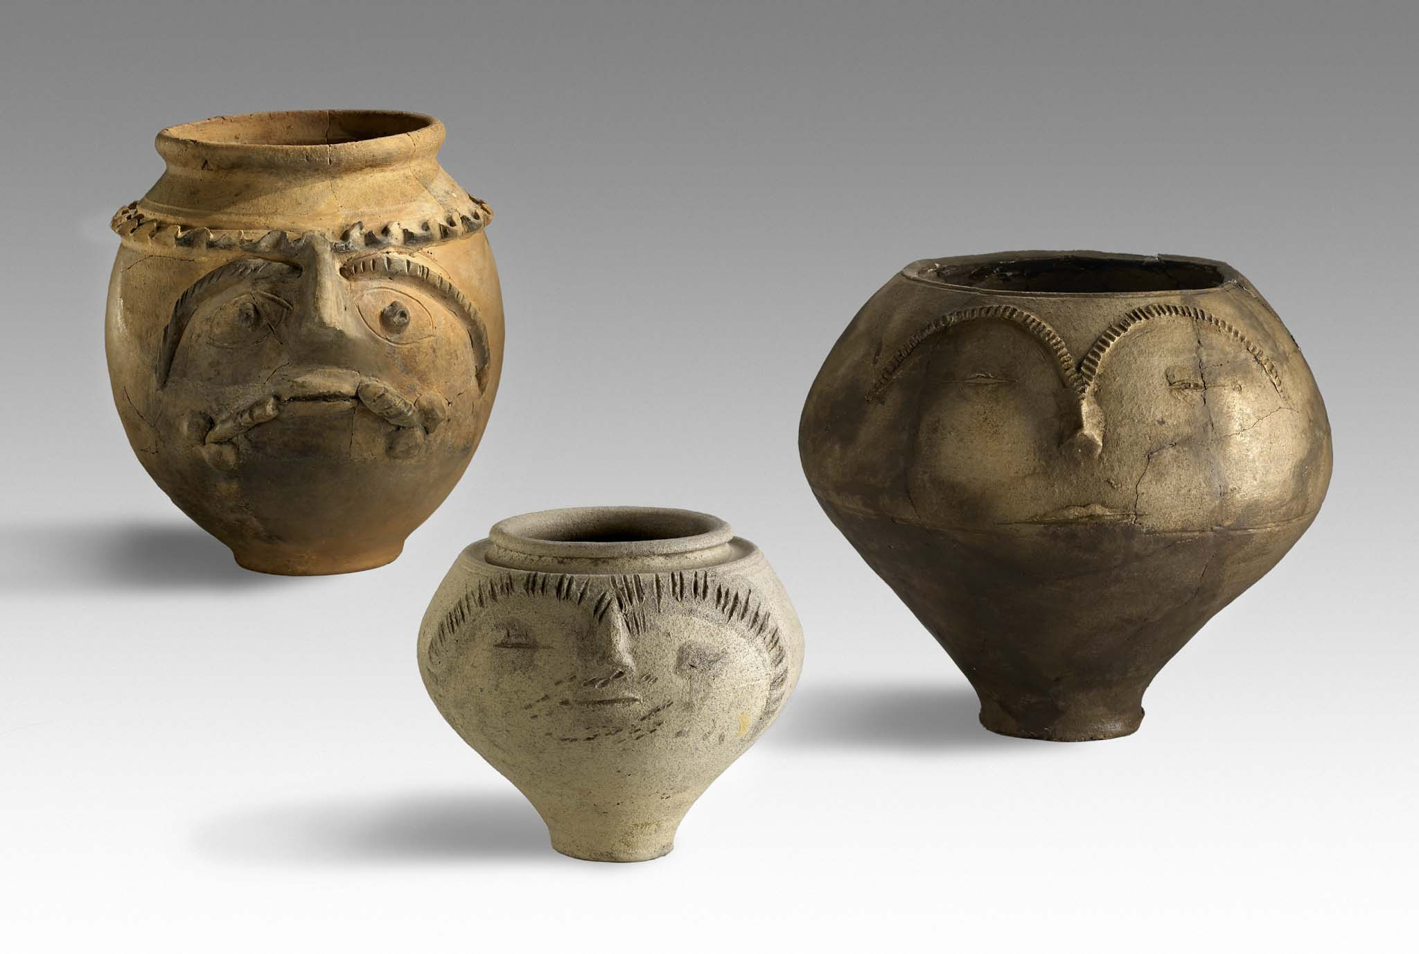

29th Congress of the Rei Cretariae Romanae Fautores

Xanten, Germany

21 – 26 September 2014
at the LVR-RömerMuseum in the Archaeological Park Xanten

Preliminary programme

Sunday, 21st September 2014

18.00 h Arrival and registration

18.30 h Get-together at the LVR-RömerMuseum in the
Archaeological Park Xanten

Monday, 22nd September 2014

09.00 h Opening ceremony
Milena Karabaic, Head of the LVR-Department of Culture and Environment
Dr. Martin Müller, Head of the LVR-Archaeological Park Xanten
Dr. Bernd Liesen, LVR-Archaeological Park Xanten
Dr. Philip Kenrick, President of the RCRF

Eastern provinces

10.00 h Liz. phil. Thomas Hintermann, The Grey Ware with Black Gloss from Ephesos

10.20 h Assoc. Prof. Dr. Mehmet Tekocak, Roman Fine Ware Found in Kelenderis Agora Basilica Excavation

10.40 – Coffee break
11.00 h

11.00 h Asuman Lätzer-Lasar M.A., Roman Ceramics from Ainos, East Thrace (Turkey)

11.20 h Dr. des. Erika Cappelletto, New Acquisitions from the Hel- lenistic-Roman-Byzantine East Necropolis of Hierapolis in Phrygia (Thanatos-Project – University of Oslo)

11.40 h Assoc. Prof. Dr. Ertekin Doksanaltı, The Roman and Late Roman Pottery from the New Excavations in Knidos

12.00 – Lunch break
13.00 h

13.00 h Dr. Derya Erol, Agora of Smyrna Found Terra Sigillata and Late Roman Ware between 2000-2005

13.20 h Dr. Denis Zhuravlev, Knidian Relief Ware in the Northern Pontic Area

13.40 h Dr. Diana Dobreva, Tracing Networks in the Black Sea. The Case of the Sinopean wine

14.00 h Anna Smokotina, Late Roman Amphorae from Tyritake

14.20 h Mag. Veronika Sossau, Keramik aus dem spätantiken Workshop eines milesischen Wohnhauses

Africa

14.40 h Dr. Lisa Peloschek – Laura Rembart, The Multiplicity of Aswan Pink Clay Pottery (Roman Times to Late Antiquity). Synchronising Shape Repertoire, Clay Pastes and Firing Properties

15.00 h Dr. Mohamed Kenawi, Amphorae Kilns in Western Mar- marica – Libya: Egyptian Amphora AE 3 in Transition

The Balkans and the Danube region

15.20 h Martin Auer M.A. – Dr. Malgorzata Daszkiewicz, Local and Imported Pottery in Municipium Claudium Aguntum –
A Discussion of Economic Spaces based on Archaeometric Analyses

15.40 h Dr. Izida Berger-Pavić, Becher mit Karniesrand
Hees 2/Stuart 2 und ihre Derivate aus der Zivilstadt von Carnuntum, Pannonien. Importe aus den germanischen Provinzen und Gallia Belgica und lokale/regionale Pro- dukte

16.00 – Coffee break
16.20 h

16.30 – Guided tours through the LVR-RömerMuseum and
19.00 h the LVR-Archaeological Park Xanten

Tuesday, 23rd September 2014

The Balkans and the Danube region

09.00 h Dr. Philip Bes, That’s the Limit! Patterning of African and Phocaean Red Slip Wares in Central Greece

09.20 h Dr. Dénes Gabler, Rheinzaberner Sigillaten in Pannonien

09.40 h Dr. Viorica Rusu-Bolindeţ, G(AIVS) I(VLIVS) PRO(CVLVS) FE(CIT). Epigraphic and Archaeological Data on the Or- ganization and Activity of Pottery Workshops in Roman Dacia

10.00 h Dr. Tatjana Cvjeticanin, Margum Workshop: Military Pro- duction Revisited

10.20 – Coffee break
10.40 h

10.40 h Prof. Tadeusz Sarnowski, Pastus militum Inschriften und Transportamphoren aus Novae (Untermoesien)

11.00 h Prof. Eduard Krekovič, Mortaria in Graves

11.20 h Prof. Klára Kuzmová, Evidence of Paullus Ware from Lezoux in the Middle Danube Region

11.45 - Lunch break
12.45 h

13.00 h Departure to Haltern

14.30 h Welcome speech (LWL-Römermuseum Haltern)
Renate Wiechers (Deputy Director of the
LWL-Römermuseum Haltern)

14.45 - Guided Tour through the LWL-Römermuseum
19.30 h Haltern and the Archaeological Site

Wednesday, 24th September 2014

09.00 h Dr. Mariana-Cristina Popescu, Beyond the Boundaries. First-century AD Roman Pottery Discovered in the Dacian Settlement of Poiana (Galaţi County, Romania)

09.20 h Dr. Adrian Ardeţ, Terra sigillata, from Germania Superior Ornamented with the Fight of Gladiators Discovered in Dacia

09.40 h Dr. Ionuţ Bocan – Dr. Cătălina-Mihaela Neagu, Roman Lamps Discovered in the Fort at Micia (Veţel, Hunedoara County) from the Romanian National History Museum Col- lections. Preliminary Considerations Concerning Stamped Lamps

10.00 h Alexander Harizanov, A New Pottery Production Centre in the Roman Province of Thrace (II – III Century AD)

10.20 – Coffee break
10.40 h

10.40 h Dr. David Petruţ, Pottery and Military Life. A Preliminary Assessment of the Ceramic Assemblages from the Bar- racks of the Auxiliary Fort from Buciumi (Dacia Porolissen- sis)

11.00 h Piroska Hárshegyi, Supplying the Roman Army on the Pannonian Limes: Amphorae on the Territory of Aquincum

11.20 h Mag. archeol. Mirna Crnković – Prof. Slavica Filipović, Terra Sigillata Tardopadana from Mursa (Osijek – Croatia)

11.40 h Kristina Brkić BA/MA, Potters' Stamps on Plain Terra Sigil- lata from Mursa (Osijek, Croatia): the Role of the City in Commercial Relationships between Pannonia and Other Provinces of the Empire

12.00 – Lunch break
13.00 h

Raetia

13.00 h Mag. Julia Kopf, Early South Gaulish Samian Ware from the Southwestern Settlement Area of Brigantium/Bregenz (Austria)

13.20 h Dr. Karl Oberhofer, Stratifizierte Terra-Sigillata- Imitationen und engobierte Keramik einheimischer Form aus Brigantium/Bregenz

13.40 h Ferdinand Heimerl M.A., African Red Slip Ware, Cooking Wares and Lamps from Augusta Vindelicum/Augsburg

Gaul, Germany, Britain

14.00 h Dr. Tünde Kaszab-Olschewski, The vicus Iuliacum and its Ceramic Production

14.20 h Regula Ackermann – Pirmin Koch, Formschüsseln aus Kempraten (Gde. Rapperswil-Jona/CH)

14.40 h Carmela Franco, Trade and Distribution of Sicilian Wine. Flat-bottomed Amphorae in Northern Europe in Roman Period

15.00 h Zsolt Bendő – Dr. Eszter Harsányi – Dr. István Sajó –
Dr. György Szakmány, White Barbotine Decoration Analy- ses of three Roman Pottery Groups

15.20 – Coffee break
15.40 h

15.40 h Dr. Sandrine Marquié, The Pottery from a Burned Shop During the 3rd c. AD in Metz (Place de la République, France)

16.00 h Sascha Schmitz M.A., Scheldt-Valley Amphoren aus der Colonia Ulpia Traiana

16.30 – Poster session and pottery display
19.00 h

19.30 - Official reception of the Landschaftsverband
22.00 h Rheinland (LVR) at the Römische Herberge in the
LVR-Archaeological Park Xanten

Thursday, 25th September 2014

07.30 h Departure to Nijmegen

09.00 h Welcome Speech (Radboud University)
Prof. Dr. Eric Moormann, Holder of the Chair of
Archaeology at Radboud University

Lectures at the Radboud University, Nijmegen

Gaul, Germany, Britain

09.10 h Drs. Ryan Niemeijer, Pottery from the Large Augustan Fortress on the Hunerberg at Nijmegen

09.25 h Dr. Horacio González Cesteros, The Arrival of Hispanic Amphorae to the Augustan Military Places in the Lippe Valley. New Evidence from Oberaden, Haltern and Anrep- pen

09.45 h Drs. Marenne Zandstra, Pottery as a Guide for the
Presence of Non-mediterranean Troups in the Rhineland

10.00 h Roderick Geerts M.A. – Dr. Fabienne Vilvorder, From Clay to Container. Roman Pottery Production at the Beuken- bergweg, Tongeren (Belgium)

10.20 – Coffee break
10.40 h

10.40 h Dr. Marinus Polak, Pottery Finds from the Canabae
Legionis at Nijmegen

10.55 h Drs. René Kloosterman, Nijmegen-Holdeurn Ware from the Canabae

11.10 h Joep Hendriks, Pottery from Ulpia Noviomagus. The Maaspleïn production site

11.25 h Drs. Julie Van Kerckhove, A Characterization of the Pot- tery Production in Heerlen (Limburg, the Netherlands): Fabric Analysis and Typo-chronology

11.45 h Frederique Reigersman-van Lidth de Jeude, Pots for Past People. Burial Gifts in the Dutch Eastern River Area (1st – 3rd Century AD)

12.05 – Lunch break
13.05 h

13.05 h Drs. Tineke Volkers, Die Terra Sigillata und ARS aus der Wurte von Ezinge, Prov. Groningen

13.25 h Dr. Bernd Liesen, Lowlands Ware from Xanten

13.40 h Dr. Gerwulf Schneider, Chemical Data of Roman Pottery in Germania Inferior and Beyond

14.30 h Welcome speech (Museum Het Valkhof Nijmegen)
Dr. Marijke Brouwer, Director of Museum Het Valkhof
Dr. Stephan Weiß-König, Conservator of the finds
depot of the province of Gelderland

14.45 - Guided Tour through Museum Het Valkhof,
21.00 h Nijmegen, and Museum Kam, Nijmegen

Friday, 26th September 2014

Iberian Peninsula

09.00 h Prof. Dr. Darío Bernal-Casasola – Ricard Marlasca – Car- men G. Rodríguez-Santana – Blanca Ruiz-Zapata – Maria J. Gil – Miguel Alba, Apua Gaditana at Emerita Au- gusta. Archaeoichthyological, Epigraphical and Pa- lynological Characterization of a Beltrán II B Amphorae Content

Italy

09.20 h Dr. Michele Scalici, Amphoras from Vigna Marini Vitalini, Caere, Italy

09.40 h Dr. Carla Corti, The Bowls Form Haltern 14 in North-Italic Terra Sigillata: Production and Circulation

10.00 h Dr. Simonetta Menchelli – Giulia Picchi, Flat-bottom Am- phoras: Their Origins and Success (Ist Century BC – IInd Century AD)

10.20 – Coffee break
10.40 h

10.40 h Dr. Tiziano Cinaglia – Dr. Francesca Diosono, Light on the Water. Votive Deposits of Lamps in the Lake Nemi

11.00 h Dr. Barbara Borgers, The Role of Minor Centres in the Economy of Roman Central Italy

11.20 h Dr. Luana Toniolo, Una nuova officina di ceramica com- mune a Pompei (I,1,1): il sistema produttivo e il reperto- rio tipologico

11.40 h Foto Session

12.00 – Lunch break
13.00 h

13.00 h Dr. Matilde Carrara, Patinarum paludes per la mensa di Augusto? Scarti di “Graue Platten” e relativa fornace dalle officine ceramiche della Celsa (Roma)

13.20 h Dr. Macarena Bustamante Álvarez – Esperança Huguet – Jure Krajsek – Dr. Albert Ribera i Lacomba – Eleni Schindler-Kaudelka, Terra sigillata de Pompeya. Los mate- riales de la casa de Ariadna. De Augusto al 79dC

13.40 h Dr. Manuela Mongardi, Instrumentum inscriptum a Mu- tina: le anfore dello scavo di Viale Reiter

14.00 h Dr. Victor Martínez, Lusitanian and Spanish Fish Products in Rome: Evidence from the Palatine Hill in Rome

14.20 h Prof. Dr. Xavier Deru – Dr. Armand Desbat – Grégory Mainet, Deux ensembles augustéens de la Schola du
Trajan à Ostie

14.40 h Ilaria Manzini PhD – Dr. Caterina Venditti, Roman Ceram- ics from Fabrateria Nova. New Research Perspectives on the Relationships between the City and its Hinterland Through the Analysis of Ceramic Assemblages

15.00 h Lucia Formato M.A., Die Nordafrikanische Sigillata und Küchenkeramik aus den Castra Albana bei Albano Laziale/Rom; DAI Kampagnen 2010 und 2012

15.20 – Coffee break
15.40 h

15.40 h Dr. Carlo de Mitri, The Lagynos Ware in the Western Medi- terranean between Importations and Local Productions: the Torre Santa Sabina Wreck (Brindisi, Italy)

16.00 h Dr. Giovanni Borriello – Dr. Marco Giglio – Dr. Stefano Iavarone, Nuove evidenze sulla produzione di ceramica d’età romana in area flegrea: uno scarico di fornace da Cuma (NA)

16.20 h Dr. Girolamo de Simone – Dr. Caterina Martucci, Ampho- rae and Commercial Routes in Campania: New Evidence from 5th Century AD Contexts

16.40 h Dr. Christina Nervi, Africa/Ifrîqiya: Sardinian Assemblages of Vandal Period from Urban Excavations, Necropolis and Surveys

17.00 h Prof. Giuliana Cavalieri Manasse - Dr. Cristina Mondin, L’atelier ceramico di Piazza Arditi: materiali e strutture da un quartiere artigianale di Verona romana

17. 30 h Closing conference

18.00 – Conference of the RCRF members
19.00 h

19.30 - Closing dinner
22.30 h

(In case of two or more authors the names are listed in alphabetical order)

